

UNIversity of BarisHal

***Assignment On***

**“PRAN- RFL Group’s Expansion and Leadership in Manufacturing.”**

**Title:** Organization Strategy and Leadership.

**Submitted To:**

Md. Rashid Al Asif

Assistant Professor

Computer Science & Engineering

University of Barishal.

**Submitted By:**

Likhon Fakir

Roll: 21

Batch: 51

University of Barishal.

**Submitted Date:** 14-12- 2024

**PRAN- RFL Group’s Expansion and Leadership in Manufacturing**

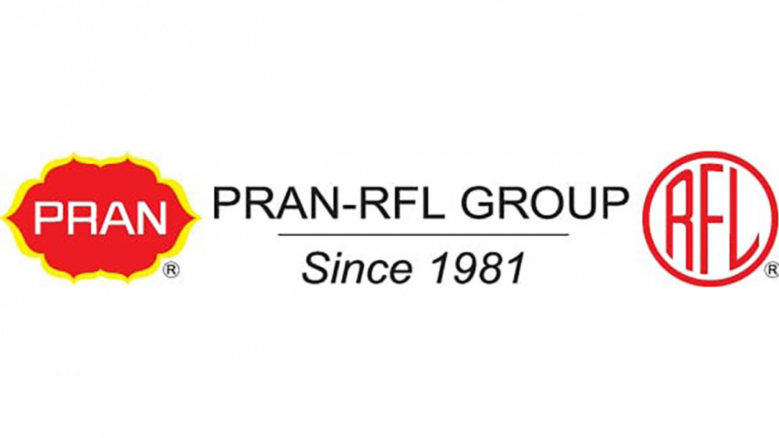

**Executive Summary**

The PRAN-RFL Group's Managing Strategy and Change study offers a thorough examination of the strategic management techniques the company uses. With an emphasis on managing change, maintaining competitive advantage, and resolving important strategic concerns, the paper explores a number of PRAN-RFL Group's strategic objectives. An outline of PRAN-RFL Group's business-level strategies and core strengths opens the report, providing insight into the company's methodology for market research and international business plans. In the framework of PRAN-RFL Group's activities, it also highlights the need of strategic brand management and marketing plans. The paper also examines PRAN-RFL Group's possibilities and challenges, with a focus on supply chain management, transformation, and change management. It emphasizes how crucial it is to adjust to new market trends and successfully manage risks and challenges in the ever-changing corporate environment. This PRAN-RFL Group Managing Strategy and Change report provides insightful information about the company's strategic management processes, emphasizing its initiatives to maintain competitive advantage, handle the difficulties of international expansion, and deal with new strategic concerns. The report makes a significant contribution to the study of strategic management in the context of a well-known business by drawing on a wide range of sources to give readers a comprehensive understanding of PRAN-RFL Group's strategic management approach. The main conclusions and analysis from the extensive report on the strategic management practices of PRAN-RFL Group are condensed in this executive summary.

Table of Contents

**1.** **Introduction** 6

Figure1.1: PRAN-RFL GROUP 6

**2.1. Vision** 8

**2.2. Mission** 8

**2.5. Core Values** 9

**3. Macro Environmental Analysis** 9

**3.1. PEST Analysis** 9

**3.2. Political Factors** 9

**3.3. Economic Factors** 9

**3.4. Social Factors** 9

**3.5. Technological Factors** 10

**3.6. Market Analysis** 10

**4. Industry Structural Analysis** 10

**5. Strategic Group Analysis** 11

**5.1. Porter’s Generic Strategies** 11

5.1.1. Cost Leadership Strategy 11

Figure 1.2: Example of Some Cost Leader Products of PRAN in the Market. 11

5.1.2. Differentiation Strategy 11

5.1.3. Focus Strategy 12

5.1.4. Market Segmentation 12

5.1.5. Diversification 12

5.1.6. Geographic expansion 12

Figure 1.4: Geographical Expansion’s 13

**6. Evaluating Business Strategy and Sustainability of Competitive Advantage** 13

**6.1. Cost leadership strategy** 13

**6.2. Growth Strategy** 13

**7. Major Strategic Issues** 14

**7.1. Analyzing Business-Level Strategies through Porter's Five Forces of Competition Framework** 14

Figure 1.5: Framework of Porter's Five Forces. 14

7.2.1. Stars 15

7.2.2. Cash Cows 15

7.2.3. Question Marks 16

7.2.4. Dogs 16

**7.3. SWOT analysis** 17

7.3.1. Opportunities 17

7.3.2. Threats 17

7.3.3. Strengths 18

7.3.4. Weaknesses 18

**8. Recommendations** 18

**9. Conclusion** 19

**10. References** 21

# 

# **Introduction**

PRAN began as a fruit and vegetable processor in Bangladesh in 1980, and after merging with RFL in 1981, it grew to become one of the country's largest corporate conglomerates. In addition to increasing in prominence over time, the business has made a substantial contribution to the nation's general socioeconomic growth. Among the millions of people in Bangladesh and the more than 145 countries where PRAN products are frequently exported, the PRAN group is today one of the most admired food and beverage brands.

Every product is made in accordance with international standards, guaranteeing the greatest degree of quality throughout the whole production process.

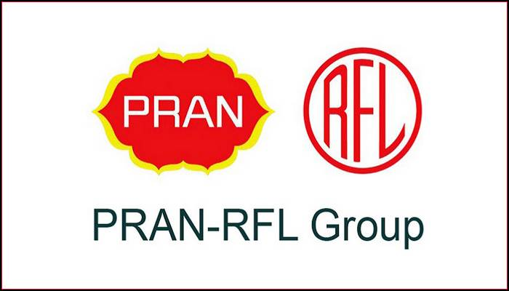

## Figure1.1: PRAN-RFL GROUP

PRAN is the first company in Bangladesh to engage in contract farming. We buy raw materials straight from farmers and transform them into hygienically packaged food and drink items at our various factories using cutting-edge gear. The brand PRAN has made a name for itself in every sector of the food and beverage business, including dairy products, juices, carbonated drinks, snacks, confections, spices, and clothing.Today, PRAN's customers appreciate the company not only for its genuine, refreshing juice drinks but also for its delicious, high-quality confections with a captivating texture and eye-catching appearance. They also plan to bring PRAN to every continent.

**2. Background of Pran-RFL group**

General (Ret) Amjad Khan Chowdhury established the PRAN-RFL Group on March 17, 1981, and it began production in Bangladesh as a modest trade firm in 1982. Before beginning to produce processed goods, the corporation began its journey by importing agricultural commodities. One of the biggest corporations in Bangladesh today, PRAN RFL Group works in a wide range of sectors, including as real estate, furniture, home appliances, plastics, and agribusiness. These days, they are posing a threat to the other global corporations. When PRAN-RFL Group first started off, exporting fruits and vegetables to foreign nations was its main priority. In 1997, the firm entered the food processing market by establishing its first fruit processing unit. Since then, the business has invested in R&D and launched new items to broaden its activities in the food sector. Additionally, PRAN-RFL Group has expanded into new businesses throughout the years. The business opened a plastic manufacturing facility in 2005 and began making a variety of plastic goods, such as bottles, containers, and home goods. Since then, the company's plastics section has expanded to rank among Bangladesh's biggest plastic producers. The PRAN-RFL Group has also entered the real estate market, creating a number of residential and commercial projects around Bangladesh. The business has set up a furniture production facility and is now creating premium furniture items for both domestic and foreign consumers. Beginning as a modest trade firm and expanding into a diversified conglomerate with a presence in several sectors, PRAN-RFL Group has a long and prosperous history. The company's emphasis on innovation, product variety, and dedication to offering its clients high-quality goods and services are all factors in its success. The PRAN-RFL Group's emphasis on quality and innovation is responsible for its success in the food sector. The firm has opened a number of food processing facilities and released a variety of goods onto the market, such as snacks, juice, dairy products, and other culinary items. To assist guarantee the quality of the raw materials used in its culinary products, PRAN-RFL Group has also set up its own agriculture sector. The PRAN-RFL Group has made large investments in the home appliance sector in addition to the food and plastic industries. The business has set up a manufacturing facility for home appliances, such as refrigerators, air coolers, fans, washing machines, and other electrical goods. The company's home appliance segment has grown to be among the biggest in Bangladesh, offering clients high-quality, reasonably priced goods. The PRAN-RFL Group's dedication to sustainability and corporate social responsibility is another factor contributing to its success across a range of sectors. The business has taken a number of steps to lessen its impact on the environment, such as cutting waste and utilizing renewable energy sources. Additionally, PRAN-RFL Group supports healthcare, education, and other social welfare initiatives in the areas where it works. The success of PRAN-RFL Group may be ascribed to its dedication to sustainability, quality, and innovation. The business has expanded into several other industries and built a solid reputation for offering clients top-notch goods and services. By fostering a favorable reputation among its stakeholders, the company's emphasis on corporate social responsibility has also helped it succeed. PRAN is the first food processing firm in Bangladesh to get an IMS accreditation. The British Standard Occupational Health Safety Assessment Series (BS OSHAS) 18001:2007 and the Environmental Management System ISO14001:2004 are combined to form IMS. The company has adopted ISO 9001 as a guiding principle of its management system. The company is complaint to HACCP & certified with HALAL which ensures that only the best quality products are reaches to the consumers table across the Globe.

## **2.1. Vision**

Increasing Earnings the goal of PRAN-RFL Group is to become a world-class conglomerate by offering clients top-notch goods and services while upholding moral principles and encouraging sustainable growth. By utilizing its key strengths—a strong brand name, a knowledgeable team, and a diverse product portfolio—the firm hopes to realize this ambition.

## **2.2. Mission**

Hunger and poverty are curses. Through successful businesses, they hope to create jobs and help our countrymen gain respect and dignity. In each of its business categories, PRAN-RFL Group aims to dominate the market by offering clients innovative, superior goods and services. Creating value for all parties involved—shareholders, clients, staff, and the communities where the business operates—is another aspect of the company's objective. By making investments in R&D, upholding strict corporate governance guidelines, and encouraging a continuous improvement culture, PRAN-RFL Group hopes to fulfill its purpose.   
PRAN-RFL Group's significant emphasis on business-level strategy has allowed it to fulfill its vision and goal. The business has embraced a differentiation approach that allows it to keep a competitive edge in the industry while offering its clients high-quality goods and services. The differentiation strategy of PRAN-RFL Group is founded on a number of important elements, such as:

## **2.5. Core Values**

PRAN-RFL is committed to delivering excellence by taking into account the needs and expectations of its clients. The firm strives to preserve fairness and openness in all areas while concentrating on consumers to drive continuous innovation and progress. The corporate values for PRAN-RFL are-

* Consumer care
* Suppliers care
* Employee care
* Trade care

# **3. Macro Environmental Analysis**

In conducting a macro environmental analysis of PRAN-RFL Group in terms of strategic management, it's essential to consider the external factors that can impact the organization's strategic decisions and performance. Here are the key insights from my findings:

## **3.1. PEST Analysis**

A PEST analysis of PRAN-RFL Group reveals several key factors that impact the organization's strategic management and business operations

## **3.2. Political Factors**

PRAN-RFL Group operates in various countries, and as such, it is subject to the political stability, government policies, and regulations in each of these regions. Political factors can significantly influence the group's operations, including trade policies, taxation, and government stability.

## **3.3. Economic Factors**

Economic factors such as exchange rates, inflation, and economic growth directly impact PRAN-RFL Group's business performance. The organization's operations are influenced by the economic conditions of the countries in which it operates, affecting consumer purchasing power and overall market demand.

## **3.4. Social Factors**

The sociocultural dimension is concerned with the society’s attitude and cultural values. Nowadays it is a trend to buy exceptional things. PRAN-RFL Group also try to make something new by using plastic. So, it attracts people a lot. As a brand, they always try to ensure their quality, so people accept that. They make that kind of things that are to go with our culture.

## **3.5. Technological Factors**

The rapid pace of technological advancements presents both opportunities and challenges for PRAN-RFL Group. Embracing technological innovation is essential for the organization to enhance its operational efficiency, product development, and market competitiveness.

## **3.6. Market Analysis**

External environmental analysis and market analysis have been conducted to understand the strategic brand management and changing environment of PRAN-RFL Group. These analyses likely provide insights into the macro environmental factors affecting the group's strategic decisions.

# **4. Industry Structural Analysis**

There is a mechanistic framework to PRAN-RFL. The organization is bigger. The atmosphere of the company is steady. It features centralized, vertical, well-defined structures of command, authority, and control. Specialization permeates every aspect of the company. Departments like production, marketing, and finance are examples of their specialized functions. The duties and goals of each unit are distinct and well-defined. It is more centralized. Rules and regulations were imposed more frequently by top management as the gap between the top and bottom of the organization grew. because direct observation by upper management is not an effective way to control lower-level activity. Additionally, supervisors at lower levels are not competent enough to make choices. An understanding of the company's organizational structure, business-level tactics, and industry contributions can be gained from the accessible excerpts. The company's key competences, efficient organizational framework, and ability to fulfil product and design quality all contribute to its success. Its involvement in prefabricated industrial steel structures and steel building also illustrates the organization's varied industrial presence and skills. From primary and secondary data sources, the PRAN-RFL Group's industry structure analysis in terms of strategic management provide numerous important insights:

# **5. Strategic Group Analysis**

PRAN RFL Group, one of the largest conglomerates in Bangladesh, has been the subject of various analyses and reports. Here's a strategic group analysis based on the available information:

## **5.1. Porter’s Generic Strategies**

Porter’s strategy describes how a company is pursuing a strategy to function in the market. There are mainly 3 types of strategy mentioned by Michael Porter. Each of these have different characteristics which suits different company’s according to their field and reach. Porter's Generic Strategy analysis for PRAN-RFL Group can be outlined as follows:

### 5.1.1. Cost Leadership Strategy

PRAN-RFL Group may employ a cost leadership strategy, aiming to offer products at competitive prices while maintaining quality and unique features.

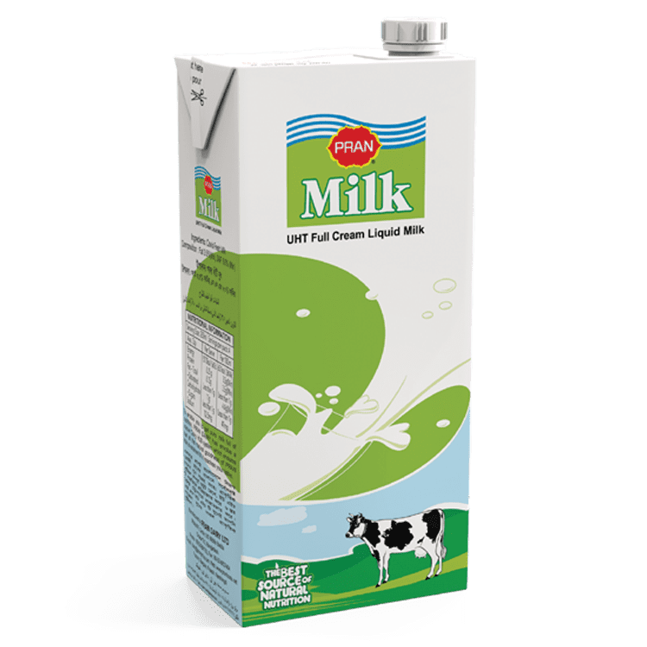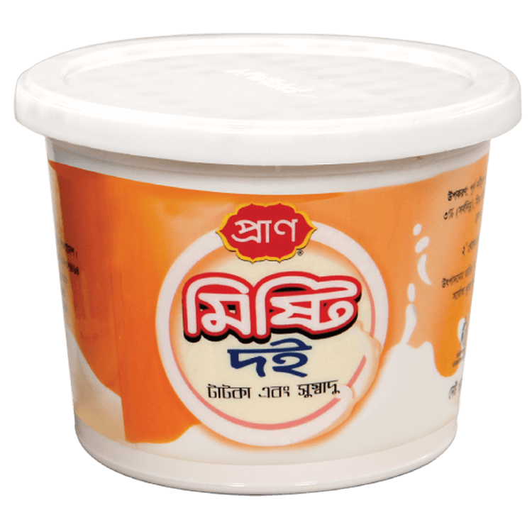

### Figure 1.2: Example of Some Cost Leader Products of PRAN in the Market.

### 5.1.2. Differentiation Strategy

The group's business level strategy likely includes a differentiation strategy, as it maintains an unmatched product and brand portfolio, leveraging its first-mover advantage and extensive distribution channels.

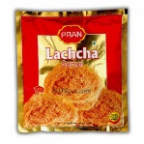

Figure 1.3: Example of Some Differential Products of PRAN in the Market

### 5.1.3. Focus Strategy

PRAN-RFL Group's strategic positioning and market presence may indicate elements of a focus strategy, targeting specific market segments with tailored products and marketing approaches.

### 5.1.4. Market Segmentation

PRAN group uses market segmentation to target specific customer segments with products that meet their needs and preferences. The company has a diverse range of products across different industries, and it uses market research to identify the needs and preferences of different customer segments. PRAN has several kinds of food for several consumers. Their target is to fulfill the consumer needs so they produce foods for every kind of people based on age and needs. Maximum PRAN products are around children and young for example, PRAN Junior Juice, Bubble Gum, PRAN Chips etc. They also export some product in other countries. They also have focus on household daily products. PRAN products are connected with everyday life.

### 5.1.5. Diversification

PRAN group has diversified its operations across multiple industries to reduce its dependence on any single industry or product category. The company operates in industries such as agribusiness, plastics, household appliances, furniture, and real estate, among others. This diversification strategy has helped the company to spread its risks and capture opportunities in various markets.

### 5.1.6. Geographic expansion

PRAN group has expanded its operations beyond Bangladesh and has established a presence in many international markets. The company has established offices and manufacturing plants in several countries, including India, Malaysia, and the Middle East, to capture new market opportunities and to diversify its revenue streams. PRAN, the largest exporter of processed food from Bangladesh, had a vision of creating a huge demand globally of those agro based products produced by native farmers of Bangladesh. Starting successful journey to export market in 1996. Export Inception of PRAN started in 1991 and the first export country is France. PRAN currently exports there products to 300 million people (approximately) over the world.

### Figure 1.4: Geographical Expansion’s

### 

|  |  |  |
| --- | --- | --- |
| Nepal | Spain | USA |
| Africa | Afghanistan | Egypt |
| India | England | UK |
| Pakistan | Scotland | Middle-east |
| Bhutan | Ireland | Indonesia |

The company in which are we researching have found that PRAN-RFL merged company are following cost leadership Strategy and also focuses on differentiation strategy. As they following the mix of these two strategies it reflects that not only, they are trying to lower the cost and capture the market but also they are trying to maintain quality. They are gaining competitive advantage by reducing cost and domination the market.

# **6. Evaluating Business Strategy and Sustainability of Competitive Advantage**

The business strategy of PRAN-RFL Group, as observed from the available search results, encompasses several key elements:

## **6.1. Cost leadership strategy**

When an organization competes based on having the lowest cost in its industry, it is following a cost leadership strategy. Seeking to attain lowest total overall cost relative to other industry competitors. A lowest cost leader is highly efficient. PRAN-RFL has been successfully using its strategy of everyday comparatively low price to attract customers. They are competing on the low price with other industries and earning higher units of profits. They are selling products at reasonable price. RFL is the market leader in plastic industries.

## **6.2. Growth Strategy**

It is a corporate strategy that’s used when an organization wants to expand the number of market served or products offered, through either its current business or new business. Expansion into new products and markets. Because of growth strategy, an organization may increase revenue, number of employees, or market share. PRAN, a leading food processor, has tripled its export earnings in the last four years to more than $144 million (TK. 1,126 core) now. To that end, the company has been exploring new export markets – from America to Africa and Asia. The group exported goods worth $50.93 million in fiscal 2014-2015 – an impressive 183.44 percent growth. Now, the group exports to 114 countries – from India to Middle East and Africa, Europe to North. The company is now producing 200 products under 10 different categories.

# **7. Major Strategic Issues**

## **7.1. Analyzing Business-Level Strategies through Porter's Five Forces of Competition Framework**

To give a bit more background, Porter's Five dynamics is a framework for examining the dynamics that drive competition in a market or sector. The framework highlights five forces—the danger of replacement products, the negotiating power of suppliers, the bargaining power of buyers, and the intensity of competitive rivalry—that can affect the degree of competition within an industry.

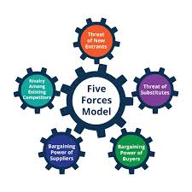

### Figure 1.5: Framework of Porter's Five Forces.

**7.2. Assessing Business Portfolio through the BCG (Boston Consulting Group) Matrix**

The PRAN-RFL Group is a large conglomerate in Bangladesh that operates in various industries including food and beverage, plastics, electronics, and agriculture. Applying the BCG matrix to the company's products and services can help to identify its growth potential and determine which products to invest in or divest from.

The BCG matrix is a tool used to analyze a company's product portfolio and identify which products should receive more or less investment based on their market growth rate and market share. The matrix categorizes products into four categories:

**Stars:** Products with a high market share in a high growth market.

**Cash Cows:** Products with a high market share in a low-growth market.

**Question Marks:** Products with a low market share in a high-growth market.

**Dogs:** Products with a low market share in a low growth market.

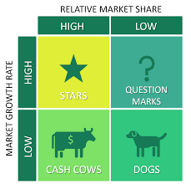Here's how PRAN-RFL Group's products fit into these categories:

### 7.2.1. Stars

PRAN's food and beverage products such as Sauce, Ketchup, Pasta, Snacks (Fried, Pallet), Chips, Lachcha Semai, Jam & Jelly and Mineral Water etc. are the stars of the company's portfolio. These products have a high market share in a high-growth market. PRAN has been able to establish itself as a market leader in the food and beverage industry in Bangladesh through a combination of aggressive marketing, continuous product innovation, and efficient supply chain management. The company's popular products include fruit juice, snacks, dairy products, and mineral water, all of which have a high demand in the local market. As a star product, PRAN should continue to invest in research and development, expand its distribution network, and explore new markets to maintain its dominant market position.

### 7.2.2. Cash Cows

PRAN's beverage products such as Carbonated Drinks, Flavored Juice, Aseptic Pack, Tin Canned, Fruit Drink, Milk Drink, Health Food Drink, Noodles and Pickles etc. are cash cows for the company. These products have a high market share in a low-growth market. PRAN has been able to achieve economies of scale in the production of these products, which has helped to reduce costs and increase profitability. These products are not likely to experience significant growth in the future, but they are stable and generate reliable cash flow. PRAN should aim to maintain its market share in this area while seeking out ways to increase profitability through cost-cutting and efficiency measures.

### 7.2.3. Question Marks

PRAN's agribusiness products such as Fruit Bar, Spices, PET Bottle, Lollypop, Instant Energy Drink, Candy, Chewing Gum, Frozen Food, Bakery, vegetable, and rice processing and chocolate products are question marks for the company. These products have a low market share in a high-growth market. PRAN has been expanding its agribusiness operations in recent years, but these products are still relatively new to the market and have not yet established a significant market share. However, the demand for processed food in Bangladesh is growing rapidly, and there is a lot of potential for PRAN to capture a larger share of this market. As a question mark product, PRAN should consider investing more in these products to increase their market share and growth potential.

### 7.2.4. Dogs

PRAN's Energy Drink, Honey, Safe Salted Drink, Mustard Oil, Flavored Milk Such As Lassi, Labang, and Instant Consumable Jelly etc. are dogs for the company. These products have a low market share in a low-growth market. PRAN has been facing stiff competition from established brands in this market, which has limited its ability to capture a significant market share. The demand for these products is not likely to grow significantly in the future, which makes it challenging for PRAN to invest in this area. As a dog product, PRAN should consider divesting from these products or finding ways to improve their market share and profitability.

Based on this analysis, PRAN-RFL Group should focus on investing more in its branded packaged food products (stars) to maintain its high market share in a high-growth market. The company should also consider investing in its agribusiness products (question marks) to increase their market share in a high-growth market.

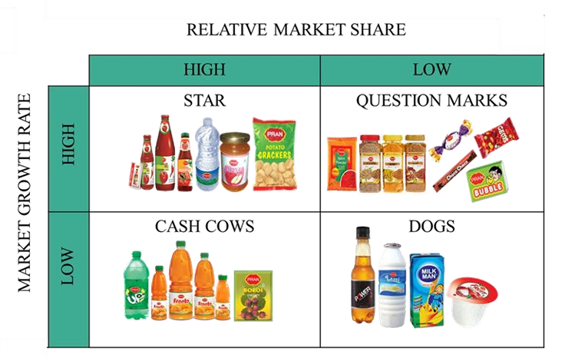

On the other hand, the company should consider reducing investment in its plastic products (cash cows) and household appliances and electronics products (dogs) and re-allocate resources to more promising products. This can help the company to optimize its product portfolio and improve its overall profitability.

## **7.3. SWOT analysis**

### 7.3.1. Opportunities

The main opportunities, facing by the Pran Food Company’s product line are as follows:

• Market study shows that consumers are showing huge interest in variety of milk.

• The maximum retailers and super shops are willing to carry the Pran Company’s products.

### 7.3.2. Threats

Every company faces threats when they newly enter into market or for the existing company. Threats facing the Pran Food Company are as follows:

• Pran has many competitors which are marketing dairy products. It has a strong competitor (Arong) in producing Chocolate Milk.

• Current political unstable situation may affect the new product launching activities.

• Uprising commodity price is also a threat for the product in newly introducing into the market.

• Bangladesh government may establish a stringent product safety law, which would entail product redesign work.

### 7.3.3. Strengths

The Pran Food Company has some strong sides. The main strengths of Pran Company are as follows:

• The Pran Company has excellent brand awareness and a high-quality image as juice and packaging product producing company.

• Dealers and sale personnel who sell the Pran’s product are knowledgeable and well trained in selling.

• The Pran Company has an efficient service network and strong distribution channel to reach the product to the consumers quickly.

### 7.3.4. Weaknesses

The Pran Food Company has some weaknesses for “Pran Chocolate Milk”. The main weaknesses of Pran’s product line are as follows:

• Pran’s line is not clearly positioned in diary product compared with Arong and Milk Vita.

• The current advertising campaign for the diary product is not particularly creative and exciting.

• The quality of core product (Milk) is as same as the competitor’s product.

• The budget of advertising and promotion is lower than its competitors’.

# **8. Recommendations**

Based on the previous discussions and topics, here are some recommendations for PRAN-RFL Group for their further improvement: Expand agribusiness operations:

PRAN-RFL's agribusiness products have the potential to capture a larger market share in a high-growth market. To achieve this, the company should invest more resources in its agribusiness operations. This could include expanding its processing facilities, increasing its procurement of raw materials, and investing in research and development to improve the quality of its products.

Continue to innovate in food and beverage products: PRAN-RFL's food and beverage products are the stars of the company's portfolio, and it is important to continue to innovate in this area to maintain its market leadership. The company should invest in research and development to create new products and improve existing ones. It could also explore opportunities to expand its product offerings in the food and beverage industry, such as organic or healthy products.

Improve efficiency in plastic products: PRAN-RFL's plastics products are cash cows for the company, but it is important to improve efficiency in this area to increase profitability. This could include measures such as reducing production costs, improving supply chain management, and increasing operational efficiency.

Consider divesting from underperforming products: PRAN-RFL's household appliances and electronics products have a low market share in a low-growth market and are dogs for the company. The company should consider divesting from these products to free up resources and focus on areas with greater growth potential.

Focus on sustainability: PRAN-RFL should focus on sustainability in all its operations to meet the changing consumer demands and ensure a long-term business outlook. It could adopt environmentally friendly practices in production and packaging, reduce its carbon footprint, and increase transparency in its supply chain.

Strengthen marketing efforts: Although PRAN-RFL has a strong presence in the market, the company could benefit from strengthening its marketing efforts. It could invest in marketing campaigns to increase brand awareness and promote new products. The company could also focus on targeted marketing to specific customer segments.

Enhance customer experience: PRAN-RFL could improve the customer experience by investing in better customer service and after-sales support. This could include implementing customer feedback mechanisms to identify areas for improvement, training employees on customer service skills, and ensuring quick and efficient resolution of customer complaints.

# **9. Conclusion**

PRAN group rapidly reaches the success by diversifying their products and promotes their products in home and abroad. They want to reach the peak of customer satisfaction. PRAN has ability and logistics to make it popular around the globe. They believe in service. Service could be from their side or from the people, institutions working with PRAN.

PRAN group's business-level strategies have helped the company to achieve its mission of becoming a world-class brand. The company's focus on product differentiation, cost leadership, market segmentation, diversification, and geographic expansion has enabled it to capture new market opportunities, reduce risks, and meet the changing needs of its customers. Additionally, these strategies have enabled the company to maintain its competitive position in industries with high levels of competitive rivalry.

PRAN is currently the most well-known household name among the millions of people in Bangladesh. By the above discussion we come to know about all the Marketing factors of PRAN Foods. As PRAN is a Bangladeshi brand so we have to support it for our own development and PRAN has to develop their technology to improve their product quality at a high position that’s why it touches the consumer hearts. As we are Bangladeshi so we have to support our local products and for this the companies have to develop their product. If it became success then we have an opportunity to be a develop country in future by internal transaction.

This report has provided an in-depth analysis of the business level strategy of PRAN-RFL Group, one of the largest conglomerates in Bangladesh. The report has started with an overview of the company's vision, mission, and background, and then delved into the different strategies adopted by the company to achieve its business objectives.

The report has analyzed the company's strategies using Porter's Five Forces model and the Boston Consulting Group (BCG) matrix. It has identified the key strengths and weaknesses of the company and highlighted areas for improvement.

Furthermore, the report has suggested that the company should strengthen its marketing efforts, enhance customer experience, diversify into new markets, improve its digital presence, and foster a culture of innovation to remain competitive in the dynamic business environment of Bangladesh and beyond.

Finally, we can say that, PRAN-RFL Group has demonstrated strong growth and market leadership over the years, and with a focus on strategic planning and implementation of these recommendations, it is poised to continue its success and growth trajectory in the future.

# **10. References**

1. PRAN-RFL Group. (2021). PRAN-RFL Group. Retrieved January 22, 2023, from Access Date: February 17, 2023. http://dx.doi.org/10.13140/RG.2.2.16500.22406
2. Sakib, N. (2 b\]018), PRAN-RFL group- a rising market giant of Bangladesh, Academia, Retrieved from https://www.academia.edu/33998758/Term_paper_on_pran_rfl_group_10122100104_con version_gate, Accessed on February 21, 2023,
3. Hooley, G., Piercy, N. F., & Nicoulaud, B. (2012). Marketing strategy and competitive positioning. Pearson Education.
4. Porter, M. E. (2008). The five competitive forces that shape strategy. Harvard Business Review, 86(1), 78-93
5. Boston Consulting Group. (2021). How to use the BCG matrix. Retrieved January 22, 2023, from https://www.bcg.com/en-us/capabilities/strategy/how-to-use-bcg-matrix. Access Date: February 17, 2023
6. Kotler, P., & Armstrong, G. (2010). Principles of marketing. Pearson Education.
7. Makadok, R. (2010). The BCG matrix and the product life cycle: The future of product portfolio
8. analysis? Journal of product innovation management, 27(1), 17-22. Access Date: February 17, 2023.
9. Bangladesh University of Business and Technology. (n.d.). PRAN-RFL (1) Report on PRAN-RFL Group. Study Material. Retrieved from https://www.studocu.com/row/document/bangladesh-university-of-business-and technology/business-introduction/pran-rfl-1-report-on-pran-rfl-group/31964360. Accessed on February 17, 2023.
10. M. Khan, Rizwan & Islam, Ariful (2019). Core competencies & business level strategy of PRAN-RFL group. Dokumen. Retrieved from https://dokumen.tips/business/core competencies-business-level-strategy-of-pran-rfl-group.html. Accessed on February 17, 2023.
11. Islam, M. A. (2015). Analytical Review of PRAN-RFL Group. Academia. Retrieved from https://www.academia.edu/12117166/Analytical_review_of_Pran_Rfl_group. Accessed on February 17, 2023.